EENG 385 - Electronic Devices and Circuits

Lab 4 – Pseudo Ramp Generator

Just Solutions

# System Architecture

Table 1: The output of the 555 Timer simulations from the prior two labs.

|  |  |
| --- | --- |
| Quantity | 555 Timer Simulation |
| Time high (us) | 39.0 us |
| Time low (us) | 275 us |
| Period (us) | 314 us |
| Frequency (kHz) | 3.18 kHz |
| Duty Cycle | 12.4% |

We will come back to this table through the course of the lab.

# Analysis Pseudo Ramp Generator

1. Determine the gain of the non-inverting op amp in Figure 3.

**Gain = 1+ R5/R6 = 1+4.7k/3.3k = 2.42**

1. Determine the time constant for the RC network on the non-inverting input of the op amp in Figure 3.

**R = 100k C = 10nf RC = 100*103 * 10*10-9 = 1000*10-6**

1. Write an equation describing the voltage of the charging capacitor. Assume that VCC = 9V.

**v(t) = 9*(1-e-t/1000us)**

# Analysis Pseudo Ramp Generator in BJT Curve Tracer

1. During one period, how long is the 555PULSE signal at 0V and how long is 555PULSE at 9V? Hint, Table 1.

**555PULSE stays low for 275us and goes high for 39us.**

1. When the base of Q3 is driven towards 9V, what will happen to the capacitor C8? Will it be discharged to 0V or allowed to accumulate charge?

**When the base of Q3 is driven towards 9V, capacitors C8 will be discharged to 0V.**

1. When the base of Q3 is driven towards 0V, what will happen to the capacitor C8? Will it be discharged to 0V or allowed to accumulate charge?

**When the base of Q3 is driven towards 0V, capacitors C8 will be allowed to charge.**

1. During one period of the 555PULSE signal, how long will the 10nF capacitor in the Pseudo Ramp Generator by held at 0v?

**The 10nF capacitor will be held at 0V while the 555PULSE signal is at 9V. The 555PULSE is at 9V for 39us.**

1. During one period of the 555PULSE signal, how long will 10nF capacitor in the Pseudo Ramp Generator be allowed to charge?

**The 10nF capacitor will be allowed to charge while the 555PULSE signal is at 0V. The 555PULSE is at 0V for275us.**

1. Assume that the 10nF capacitor is totally discharge. During one period of the 555PULSE signal, what is the highest voltage the 10nF capacitor will obtain?

**During one period of the 555PULSE waveform, the waveform will be at 0V for 275us.**

**v(t) = 9*(1-e-275us/1000us) = 2.16V**

1. Using the same assumptions as in the previous problem, what will be the highest voltage on the op amp output? Hint, multiply the previous answer by the gain of the op amp found you found in an earlier question. Put this answer in the Analysis column of Table 2 at the end of the lab.

**2.16V * 2.42 = 5.24V**

**Excel**

**Vfinal = 2.225 Delta = 0.054**

**Simulation Pseudo-Ramp Generator**

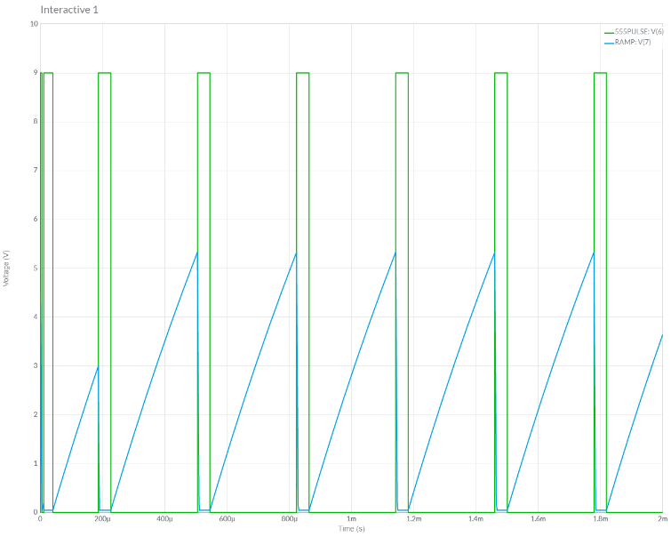

**Assemble Pseudo Ramp Generator**

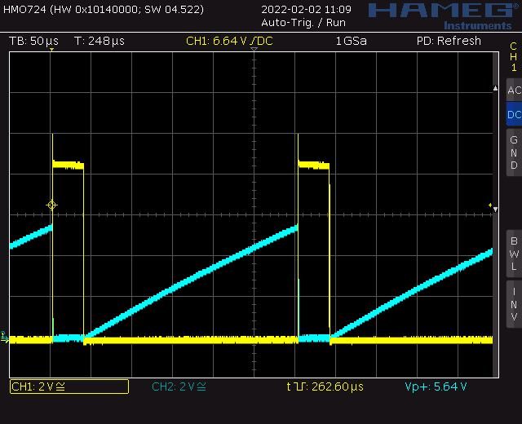

# Turn in:

Table : Summary of the voltage produced by the Pseudo Ramp Generator.

|  |  |  |  |
| --- | --- | --- | --- |
| Quantity | Analysis | Simulation | Assemble |
| Ramp Amplitude | 5.24V | 5.34V | 5.64V |